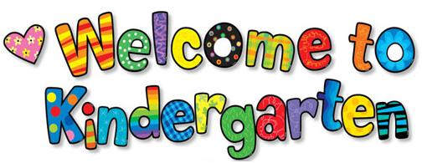

Hello, Kindergarteners and Kindergarten Families! My name is Mrs. Chrencik and I am so excited to welcome you to the start of our school year at Pine Run. What an exciting time!

Throughout the year we will make lots of friends, explore Earth, and find out lots of fun facts about the human body. We will also learn about letters & words, numbers & shapes and practice being positive kids for character. 😊

I have lived in Bucks county with my husband and three children for over 12 years. We love to hike, play outside and spend time with our black cat, Jax, and our black lionhead rabbit, Maxine. I cannot wait to meet each of you and find out what you like to do for fun!

See you soon!

Mrs. Chrencik